Type

>>> nohup python ./finite_well.py > finite_well.out &

Once the job is complete, type

>>> gnuplot

>>> load ‘psi.gnu’

>>> load ‘energy.gnu’

The plot files will need modified to your current directory. Modify Line 15 of energy.gnu and Line 13 of psi.gnu appropriately.

Wait until the EPS files are generated, and then type

>>> exit

>>> epstopdf psi.eps psi.pdf

>>> epstopdf energy.eps energy.pd

The equation to solve for the finite well changes depending on the location. Inside the well, there is a finite potential, but outside the well it is a free electron.

$$\frac{1}{Δ^{2}}\left(\begin{matrix}-2-V_{0}Δ^{2} & 1 & 0… & 0 \\ 1 & -2-V_{1}Δ^{2} & 1 & …0 \\ … & 1 & … & 1 \\ 0… & …0 & 1 & -2-V_{n}Δ^{2}\end{matrix}\right)\left(\begin{matrix}ϕ_{0} \\ ϕ_{1} \\ … \\ ϕ_{n}\end{matrix}\right)=-ϵ_{j}^{'}\left(\begin{matrix}ϕ_{0} \\ ϕ_{1} \\ … \\ ϕ_{n}\end{matrix}\right)$$

Unlike the simple harmonic oscillator, these energy values are not linear. This is because the energies follow an exponential trendline.

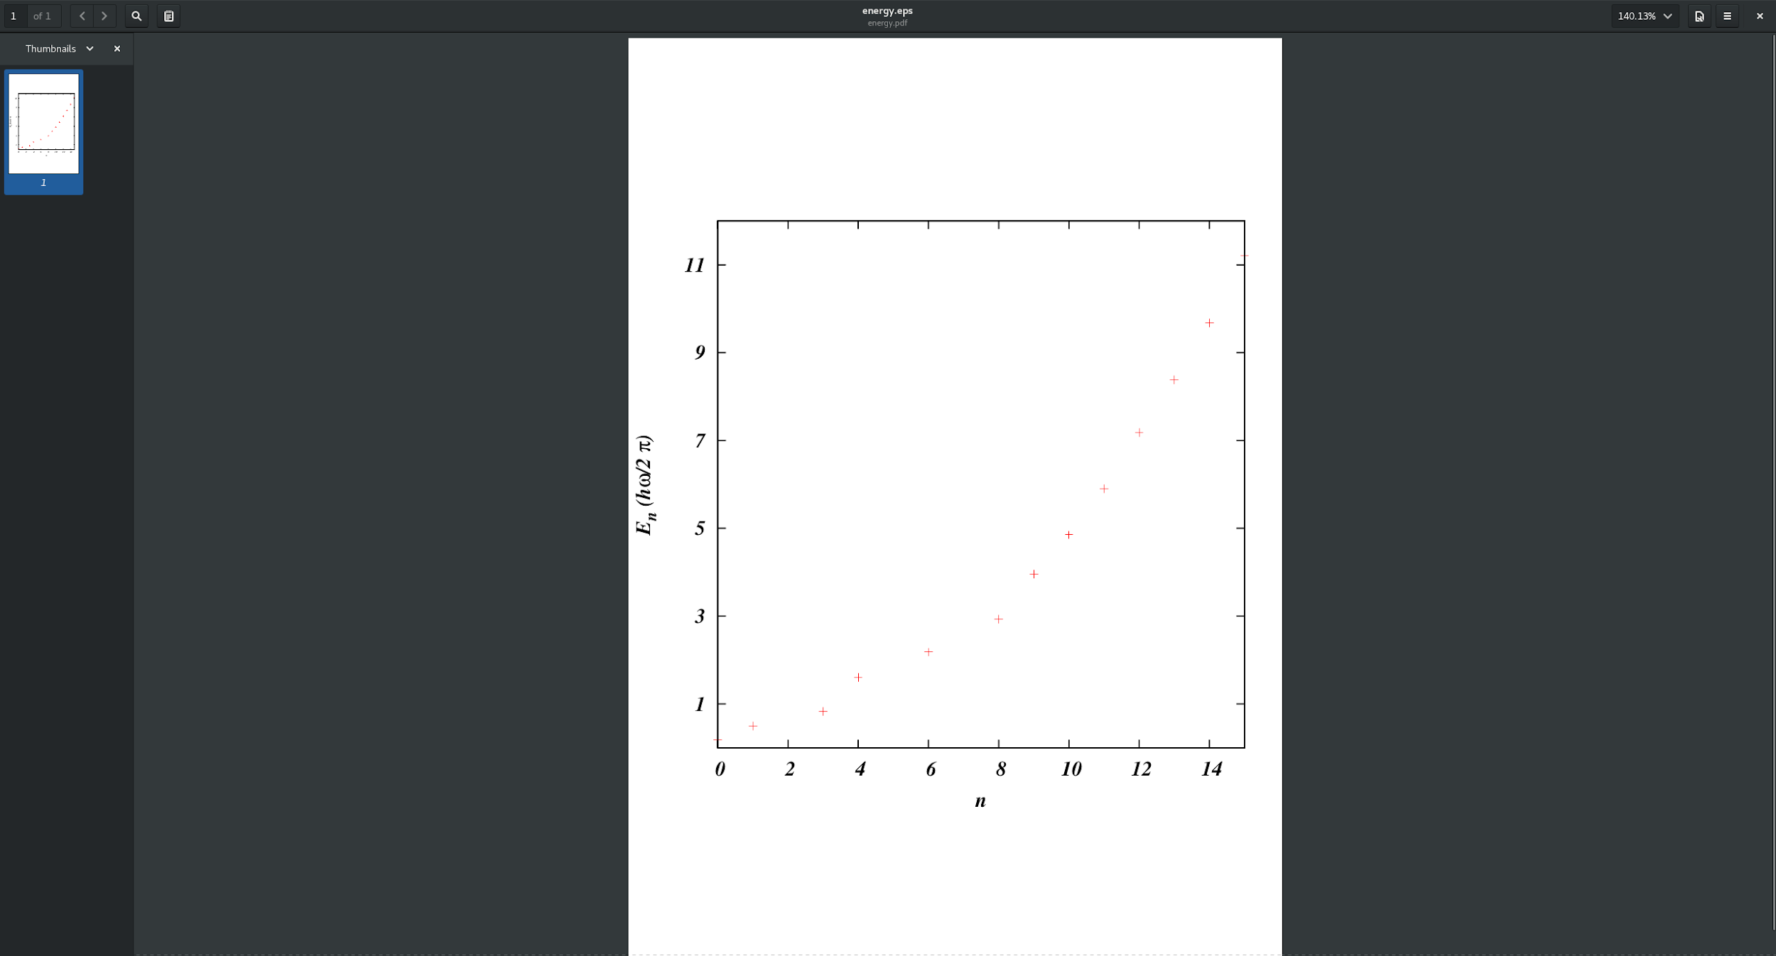

From the wavefunction analysis, we can see the even sets of n have even symmetry. The odd sets intersect the origin and have odd symmetry. Each wavefunction tends to zero as it approaches the extremes of the x axis.

